A000-Afr-Egy-Bast and Bastet

Case No. 2

Bast and Bastet goddess in cat form, faience amulets.

Fig. 1. Bast head medallion as lioness with male mane below head, green glazed faience over terracotta, suspension hole through medallion, perhaps Old Kingdom.

Fig. 2. Bastet seated on a rectangular base, rear suspension loop, 4.6 gm (0.1623 oz.), 43.65 mm. high (1.72 in.), ca. fifth century BCE. From the collection of the Late Michael Verney-Elliott, London.

Fig. 3. Bastet seated on a rectangular base, green glazed, no rear suspension loop, ca. fifth century BCE.

"Bast" ()incorporated the hieroglyph , *bȝs* [bes], "ointment jar," associated with protective salves (Quirke 1992). In her original aspect in the second dynasty she was associated with a lioness-headed woman, then later as a cat in the Middle Kingdom, then as a cat-headed woman at the end of the New Kingdom and finally as the cat of *Re* in the Late Period. This evolution of Bast from a lioness to a cat was accompanied by a change in her name from Bast to Bastet, which incorporated an additional feminine suffix. This transformation from Bast to Bastet may reflect her diminished role in the Egyptian pantheon, when [Sekhmet](http://en.wikipedia.org/wiki/Sekhmet), a similar lioness war deity, became increasingly more dominant in the unified culture of Lower and Upper Egypt. Amulets of cats were given as New Year gifts at her festival when the goddess was believed to be the bestower of protection countering the darker forces of the "Demon Days" that occurred at the end of the Egyptian Year (Wilkinson 2003:178). In line with this function as protectress, Bast's name () incorporated the hieroglyph , *bȝs* [bes], "ointment jar," which was associated with protective salves (Quirke 1992).

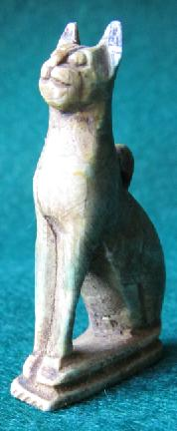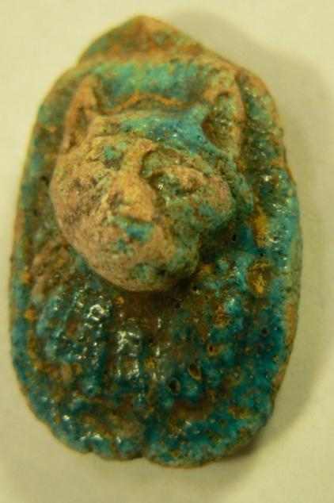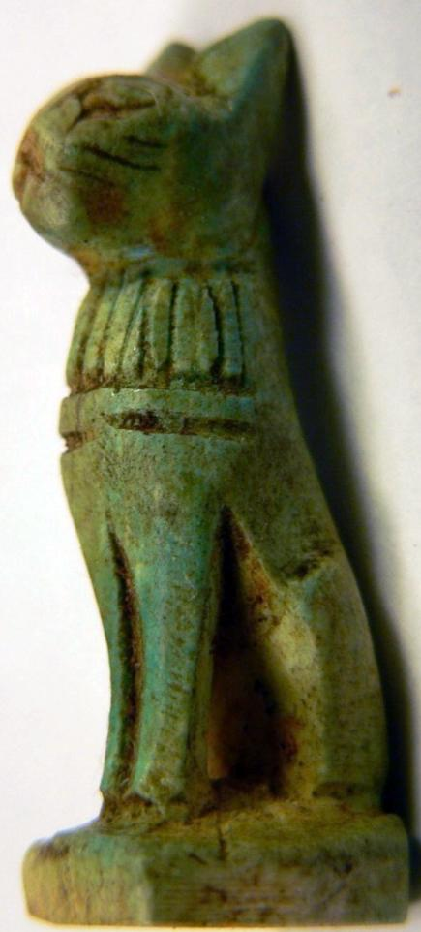The temple of Bast's cult was in the town of *PR BȝST (Per-Bast) [in Greek:* Βούβαστις; English: *Bubastis*],

"House of Bast," which Herodotus **(**Book 2, chapter 138) described first-hand in ca. 450 BCE: "Save for the entrance, it stands on an island; two separate channels approach it from the Nile, and after coming up to the entry of the temple, they run round it on opposite sides; each of them a hundred feet wide, and overshadowed by trees. The temple is in the midst of the city, the whole circuit of which commands a view down into it; for the city's level has been raised, but that of the temple has been left as it was from the first, so that it can be seen into from without. A stone wall, carven with figures, runs round it; within is a grove of very tall trees growing round a great shrine, wherein is the image of the goddess; the temple is a square, each side measuring a furlong. A road, paved with stone, of about three furlongs' length leads to the entrance, running eastward through the market place, towards the temple of Hermes; this road is about four hundred feet wide, and bordered by trees reaching to heaven." It was in this landscape that the festival of Bastet occurred as Herodotus witnessed it (Book 2, chapter 60): "Barges and river craft of every description, filled with men and women, floated leisurely down the Nile. The men played on pipes of lotus. the women on cymbals and tambourines, and such as had no instruments accompanied the music with clapping of hands and dances, and other joyous gestures. Thus did they while on the river: but when they came to a town on its banks, the barges were made fast, and the pilgrims disembarked, and the women sang, playfully mocked the women of that town and threw their clothes over their head. When they reached Bubastis, then held they a wondrously solemn feast: and more wine of the grape was drank in those days than in all the rest of the year. Such was the manner of this festival: and, it is said, that as many as seven hundred thousand pilgrims have been known to celebrate the Feast of Bast at the same time." Perhaps it was in this setting that these amulets were gifted to festival participants.

References:

Herodotus. 1920. *History*, *Books 1 and 2*, ed. H. Stein (et al.) with an English translation by A. D. Godley. Cambridge, Mass.: Loeb Classical Library, Harvard University Press.

Quirke, Stephen. 1992. *Ancient Egyptian Religion*. London: British Museum Press.

Wilkinson, Richard H. 2003. *The complete gods and goddesses of ancient Egypt*. London: Thames and Hudson.

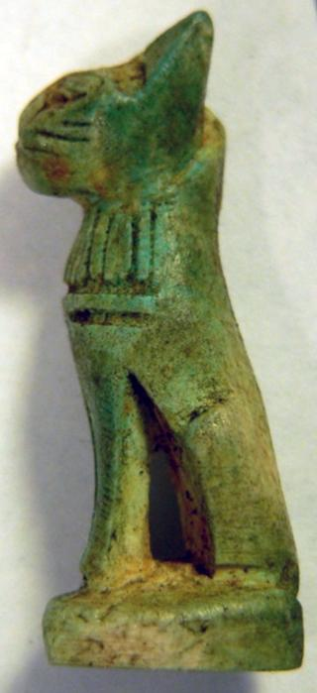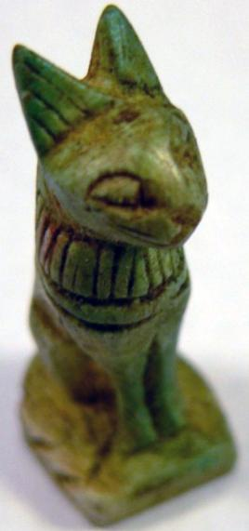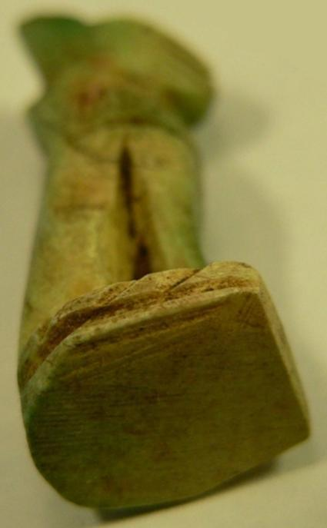

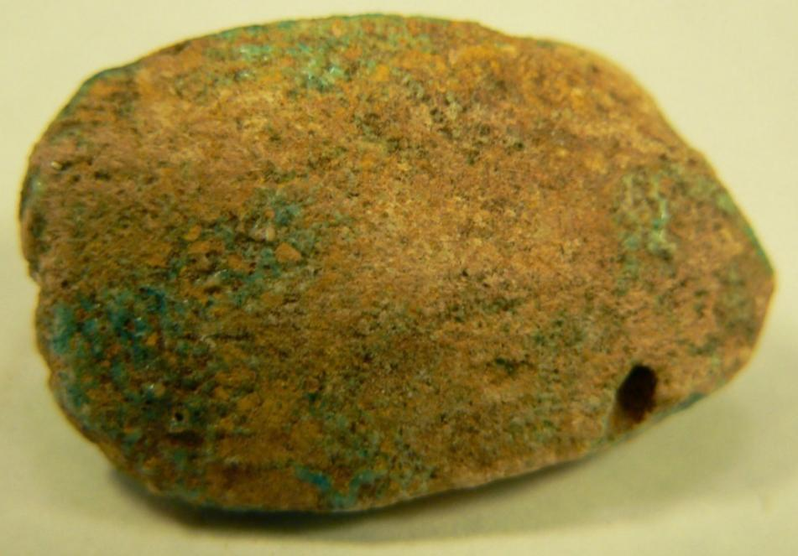 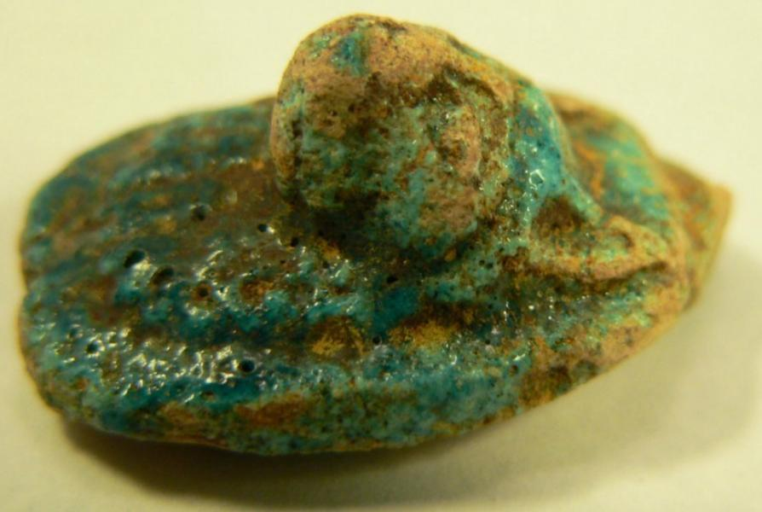

|  |
| --- |
| Shipping details |
| **Ralph J Coffman Jr**  149 Atlantic Ave  Swampscott MA 01907-2427  United States |

## Order details

|  |  |  |  |
| --- | --- | --- | --- |
| **Item title** | **Available actions** | **Shipping & handling (estimated delivery*)** | **Price** |

[Printer version](http://payments.ebay.com/ws/eBayISAPI.dll?ViewPaymentStatus&transid=0&userloginid=802-867&printerversion=true&itemid=390515814566)

|  |  |  |
| --- | --- | --- |
| Seller: | [**Member id** russelliott](http://myworld.ebay.com/russelliott) ( [**Feedback Score Of** 4536](http://feedback.ebay.com/ws/eBayISAPI.dll?ViewFeedback&userid=russelliott)) | [Contact seller](http://contact.ebay.com/ws/eBayISAPI.dll?ShowCoreAskSellerQuestion&frm=3998&iid=390515814566&redirect=0&requested=russelliott) |

|  |  |  |  |  |
| --- | --- | --- | --- | --- |
| Paid on Dec-23-12 via PayPal | | | | |
|  |  |  |  |  |

|  |  |  |  |  |  |  |  |  |
| --- | --- | --- | --- | --- | --- | --- | --- | --- |
|  | [**Item Title:**Authentic Ancient Egyptian Baby Horus & Shabti Figurines**- opens in a new window or tab**](http://cgi.ebay.com/ws/eBayISAPI.dll?ViewItem&item=390515814566)  **Item Id:**390515814566 - Price: GBP 207.55  Quantity:1  **eBay note:** Payment was recorded and this unpaid item case has been closed. | |  | | --- | |  | | |  |  | | --- | --- | | [Leave feedback](http://feedback.ebay.com/ws/eBayISAPI.dll?LeaveFeedbackShow&useridfrom=802-867&useridto=russelliott&item=390515814566&transactid=0) |  | | | Standard Int'l Postage : **GBP 9.99**  Estimated delivery: Varies* You can [contact the seller](http://contact.ebay.com/ws/eBayISAPI.dll?ShowCoreAskSellerQuestion&frm=3998&iid=390515814566&SSpagename=PageAskSellerQuestion_VI&redirect=0&requested=russelliott) for more information. | GBP 207.55 |



|  |  |  |  |  |  |  |
| --- | --- | --- | --- | --- | --- | --- |
|  | | | |  | | |
|  | | |  | | --- | |  | | [Ad Feedback](javascript:void(0);)|[AdChoice **- opens in a new window or tab**](javascript:void(0);) | | | | |  |  |  |  |  |  |  |  |  |  |  |  |  |  |  |  |  |  | | --- | --- | --- | --- | --- | --- | --- | --- | --- | --- | --- | --- | --- | --- | --- | --- | --- | --- | | |  | | --- | | |  |  |  |  |  |  |  |  |  |  |  |  |  |  |  | | --- | --- | --- | --- | --- | --- | --- | --- | --- | --- | --- | --- | --- | --- | --- | | |  |  | | --- | --- | | Subtotal: | GBP 207.55 | |  | | | Shipping & handling: | GBP 9.99 | |  | | |  | | |  | | | Total: | GBP 217.54 | | | | |  |
|  |  | |  | | | |
|  | Shipping details | |  | | | |
|  | **Ralph J Coffman Jr**  149 Atlantic Ave  Swampscott MA 01907-2427  United States | |  | | | |

## Order details

|  |  |  |  |
| --- | --- | --- | --- |
| **Item title** | **Available actions** | **Shipping & handling (estimated delivery*)** | **Price** |

[Printer version](http://payments.ebay.com/ws/eBayISAPI.dll?ViewPaymentStatus&transid=1166398815015&userloginid=802-867&printerversion=true&itemid=251213746070)

|  |  |  |
| --- | --- | --- |
| Seller: | [**Member id** pickitsellit](http://myworld.ebay.com/pickitsellit) ( [**Feedback Score Of** 13](http://feedback.ebay.com/ws/eBayISAPI.dll?ViewFeedback&userid=pickitsellit)) | [Contact seller](http://contact.ebay.com/ws/eBayISAPI.dll?ShowCoreAskSellerQuestion&frm=3998&iid=251213746070&redirect=0&requested=pickitsellit) |

|  |  |  |  |  |
| --- | --- | --- | --- | --- |
| Paid on Jan-18-13 via PayPal | | | | |
|  |  |  |  |  |

|  |  |  |  |  |  |  |  |  |
| --- | --- | --- | --- | --- | --- | --- | --- | --- |
|  | [**Item Title:**Ancient Egyptian God Bastet Statuette Greco-Roman Period 395 AD**- opens in a new window or tab**](http://cgi.ebay.com/ws/eBayISAPI.dll?ViewItem&item=251213746070)  **Item Id:**251213746070 - Price: US $34.00  Quantity:1  Having a problem with this purchase? [We can help](javascript:;) | |  | | --- | |  | | |  |  | | --- | --- | | [Leave feedback](http://feedback.ebay.com/ws/eBayISAPI.dll?LeaveFeedbackShow&useridfrom=802-867&useridto=pickitsellit&item=251213746070&transactid=1166398815015) |  | | | Standard Shipping : **FREE**  USPS First Class Package®  Estimated delivery on or before Thu. Jan. 24 per eBay FAST 'N FREE | US $34.00 |



|  |  |  |  |  |  |  |
| --- | --- | --- | --- | --- | --- | --- |
|  | | | |  | | |
|  | | |  | | --- | |  | | [AdChoice **- opens in a new window or tab**](javascript:void(0);) | | | | |  |  |  |  |  |  |  |  |  |  |  |  |  |  |  |  |  |  | | --- | --- | --- | --- | --- | --- | --- | --- | --- | --- | --- | --- | --- | --- | --- | --- | --- | --- | | |  | | --- | | |  |  |  |  |  |  |  |  |  |  |  |  |  |  |  | | --- | --- | --- | --- | --- | --- | --- | --- | --- | --- | --- | --- | --- | --- | --- | | |  |  | | --- | --- | | Subtotal: | US $34.00 | |  | | | Shipping & handling: | FREE | |  | | |  | | |  | | | Total: | US $34.00 | | | | |  |
|  | Shipping details | |  | | | |
|  | **Ralph J Coffman Jr**  149 Atlantic Ave  Swampscott MA 01907-2427  United States | |  | | | |

## Order details

|  |  |  |  |
| --- | --- | --- | --- |
| **Item title** | **Available actions** | **Shipping & handling (estimated delivery*)** | **Price** |

[Printer version](http://payments.ebay.com/ws/eBayISAPI.dll?ViewPaymentStatus&transid=1166418499015&userloginid=802-867&printerversion=true&itemid=251213746505)

|  |  |  |
| --- | --- | --- |
| Seller: | [**Member id** pickitsellit](http://myworld.ebay.com/pickitsellit) ( [**Feedback Score Of** 13](http://feedback.ebay.com/ws/eBayISAPI.dll?ViewFeedback&userid=pickitsellit)) | [Contact seller](http://contact.ebay.com/ws/eBayISAPI.dll?ShowCoreAskSellerQuestion&frm=3998&iid=251213746505&redirect=0&requested=pickitsellit) |

|  |  |  |  |  |
| --- | --- | --- | --- | --- |
| Paid on Jan-18-13 via PayPal | | | | |
|  |  |  |  |  |

|  |  |  |  |  |  |  |  |  |
| --- | --- | --- | --- | --- | --- | --- | --- | --- |
|  | [**Item Title:**Ancient Egyptian God Bastet Bust Amulet Greco-Roman Period 395 AD**- opens in a new window or tab**](http://cgi.ebay.com/ws/eBayISAPI.dll?ViewItem&item=251213746505)  **Item Id:**251213746505 - Price: US $22.00  Quantity:1  Having a problem with this purchase? [We can help](javascript:;) | |  | | --- | |  | | |  |  | | --- | --- | | [Leave feedback](http://feedback.ebay.com/ws/eBayISAPI.dll?LeaveFeedbackShow&useridfrom=802-867&useridto=pickitsellit&item=251213746505&transactid=1166418499015) |  | | | Standard Shipping : **FREE**  USPS First Class Package®  Estimated delivery on or before Thu. Jan. 24 per eBay FAST 'N FREE | US $22.00 |



|  |  |  |  |  |
| --- | --- | --- | --- | --- |
|  | |  | | |
|  | |  | | --- | |  | | [AdChoice **- opens in a new window or tab**](javascript:void(0);) | | | |  |  |  |  |  |  |  |  |  |  |  |  |  |  |  |  |  |  | | --- | --- | --- | --- | --- | --- | --- | --- | --- | --- | --- | --- | --- | --- | --- | --- | --- | --- | | |  | | --- | | |  |  |  |  |  |  |  |  |  |  |  |  |  |  |  | | --- | --- | --- | --- | --- | --- | --- | --- | --- | --- | --- | --- | --- | --- | --- | | |  |  | | --- | --- | | Subtotal: | US $22.00 | |  | | | Shipping & handling: | FREE | |  | | |  | | |  | | | Total: | US $22.00 | | | | |  |